Smörgåsbord- menu
(Allergens marked in red. Orange, where the dish contains gluten, but can be made gluten free- please ask)
We follow best practices in safe food handling to prevent cross-contamination. However, unfortunately, we cannot guarantee our products are 100% free of any specific allergen. Allergens listed here refer to the ingredients we use.

 | 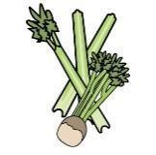 | 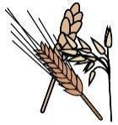 | 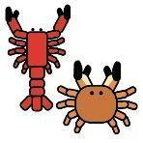 | 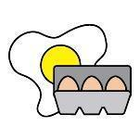 | 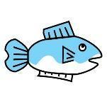 | 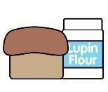 | 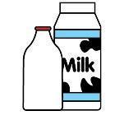 | 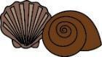 | 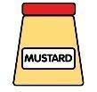 | 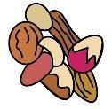 | 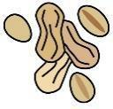 | 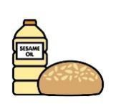 |  | 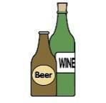
 | Celery | Cereals containing gluten* | Crustaceans | Eggs | Fish | Lupin | Milk | Mollusc | Mustard | Nuts† | Peanuts | Sesame seeds | Soya | Sulphur Dioxide
Mixed leaf salad
Vegetarian meatballs
Tarts
 | Celery | Cereals containing gluten* | Crustaceans | Eggs | Fish | Lupin | Milk | Mollusc | Mustard | Nuts† | Peanuts | Sesame seeds | Soya | Sulphur Dioxide
Vasterbotten paj |  | Wheat
sour cream and fish roe
Mushroom tart |  | Wheat
Smoked salmon tart |  | Wheat
Pates
 | Celery | Cereals containing gluten* | Crustaceans | Eggs | Fish | Lupin | Milk | Mollusc | Mustard | Nuts† | Peanuts | Sesame seeds | Soya | Sulphur Dioxide
Smoked mackerel
Smoked trout
Mushroom salad
Breads
 | Celery | Cereals containing gluten* | Crustaceans | Eggs | Fish | Lupin | Milk | Mollusc | Mustard | Nuts† | Peanuts | Sesame seeds | Soya | Sulphur Dioxide
Porcini brioche |  | Wheat
Archipelago bread |  | Wheat and rye
Apple bread |  | Wheat |  |  |  |  |  |  |  | Hazelnut
Salads
 | Celery | Cereals containing gluten* | Crustaceans | Eggs | Fish | Lupin | Milk | Mollusc | Mustard | Nuts† | Peanuts | Sesame seeds | Soya | Sulphur Dioxide
Spelt salad with cranberries and butternut squash |  | Spelt gluten
Lemon hasselback potatoes
Potato salad
Roasted carrots with cranberries,
Radish and egg salad |  | Rye
Roasted cauliflower with goats cheese and apple |  |  |  |  |  |  |  |  |  | Hazelnuts
Grilled figs with pecans |  |  |  |  |  |  |  |  |  | Pecans
Puddings
 | Celery | Cereals containing gluten* | Crustaceans | Eggs | Fish | Lupin | Milk | Mollusc | Mustard | Nuts† | Peanuts | Sesame seeds | Soya | Sulphur Dioxide
Blueberry tart |  | Wheat and rye
Danish apple drømmekage |  | Wheat
Pear and almond tart |  | Wheat
Sticky rye date cake |  | Wheat and rye

