Find your inner Scandi- menu
(Allergens marked in red. Orange, where the dish contains gluten, but can be made gluten free- please ask)
We follow best practices in safe food handling to prevent cross-contamination. However, unfortunately, we cannot guarantee our products are 100% free of any specific allergen. Allergens listed here refer to the ingredients we use.

Starters | 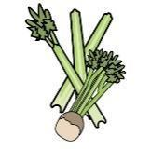 | 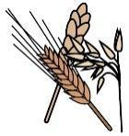 | 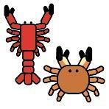 | 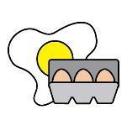 | 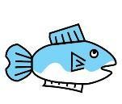 | 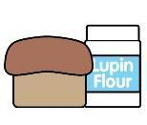 | 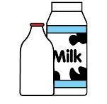 |  | 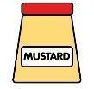 | 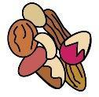 | 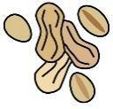 | 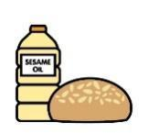 |  | 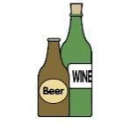
 | Celery | Cereals containing gluten* | Crustaceans | Eggs | Fish | Lupin | Milk | Mollusc | Mustard | Nuts† | Peanuts | Sesame seeds | Soya | Sulphur Dioxide
archipelago bread with ricotta and dill pesto |  | Wheat and rye
Karelian pies |  | Wheat and rye
egg butter
smoked salmon
Potato and wild garlic soup
Mains
 | Celery | Cereals containing gluten* | Crustaceans | Eggs | Fish | Lupin | Milk | Mollusc | Mustard | Nuts† | Peanuts | Sesame seeds | Soya | Sulphur Dioxide
Wild mushroom tart |  | Wheat
Jansson’s Temptation
Vegetarian meatballs |  | Wheat  Can be made gluten free |  |  |  |  |  |  |  |  |  |  |  | x
Side dishes
 | Celery | Cereals containing gluten* | Crustaceans | Eggs | Fish | Lupin | Milk | Mollusc | Mustard | Nuts† | Peanuts | Sesame seeds | Soya | Sulphur Dioxide
Green beans with hazelnut dill butter |  |  |  |  |  |  |  |  |  | Hazelnut
Mashed potatoes
Lemon hasselback potatoes |  |  |  |  |  |  | Wheat. Can be made gluten free
Roasted carrots with cranberries
Pumpkin apple and cabbage salad
Puddings |  |  |  |  | W
 | Celery | Cereals containing gluten* | Crustaceans | Eggs | Fish | Lupin | Milk | Mollusc | Mustard | Nuts† | Peanuts | Sesame seeds | Soya | Sulphur Dioxide
Pear and almond tart |  | Wheat
Sticky rye date cake |  | Wheat and rye
Apple and lingonberry crumble |  | Wheat. Can be made gluten free |  |  |  |  |  |  |  | Almonds

