Nordic afternoon tea
(Allergens marked in red).
We follow best practices in safe food handling to prevent cross-contamination. However, unfortunately, we cannot guarantee our products are 100% free of any specific allergen. Allergens listed here refer to the ingredients we use.

Savouries | 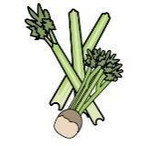 | 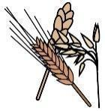 | 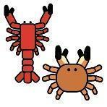 | 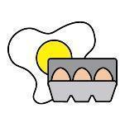 | 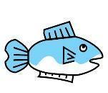 | 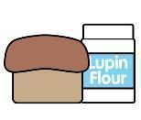 | 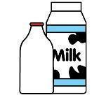 |  | 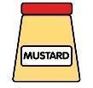 | 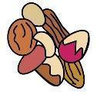 | 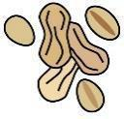 | 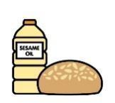 |  | 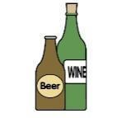
 | Celery | Cereals containing gluten* | Crustaceans | Eggs | Fish | Lupin | Milk | Mollusc | Mustard | Nuts† | Peanuts | Sesame seeds | Soya | Sulphur Dioxide
Danish white bread with dill butter |  | Wheat
topping of crayfish tails and lemon mayo
topping of salmon and lemon mayo
Vasterbotten cheese tartlet |  | Wheat
Archipelago bread with chantarelles and cream cheese |  | Wheat and rye
Croustade with quail egg |  | Wheat
Sweets
 | Celery | Cereals containing gluten* | Crustaceans | Eggs | Fish | Lupin | Milk | Mollusc | Mustard | Nuts† | Peanuts | Sesame seeds | Soya | Sulphur Dioxide
Apple dream cake |  | Wheat
Cinnamon bun |  | Wheat
Geisha cake |  | Wheat |  |  |  |  |  |  |  | Hazelnut
Fig and almond tartlet |  | Wheat |  |  |  |  |  |  |  | Almond

